BTS7960 43A DUAL H-BRIDGE HIGH-POWER MOTOR DRIVER
The BTS 7960 is a fully integrated high current half bridge for motor drive applications.
The operating voltage of 24Vdc and peak current of 43A, it has PWM capability of up to 25 kHz combined with active freewheeling.

Interfacing to a microcontroller is made easy by the integrated driver IC which features logic level inputs, diagnosis with current sense, slew rate adjustment, dead time generation and protection against over temperature, overvoltage, undervoltage, overcurrent and short circuit. The BTS7960 provides a cost optimized solution for protected high current PWM motor drives with very low board space consumption.

Specifictions:
- Input Voltage: 6 ~ 27Vdc.
- Driver: Dual BTS7960H Half-Bridge Configuration.
- Peak current: 43-Amp.
- PWM capability of up to 25 kHz.
- Control Input Level: 3.3~5V.
- Control Mode: PWM or level
- Working Duty Cycle: 0~100%.
- Over-voltage Lock Out.Under-voltage Shut Down.
- Board Size(LxWxH): 50mmx50mmx 43mm.
- Weight: ~66g.
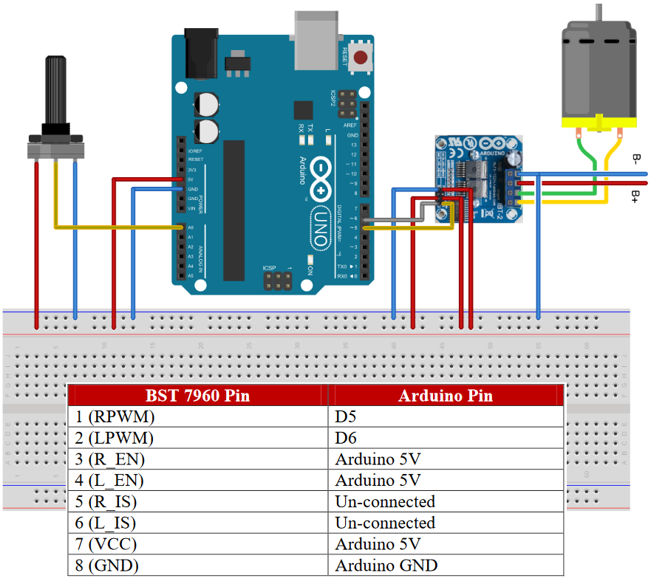
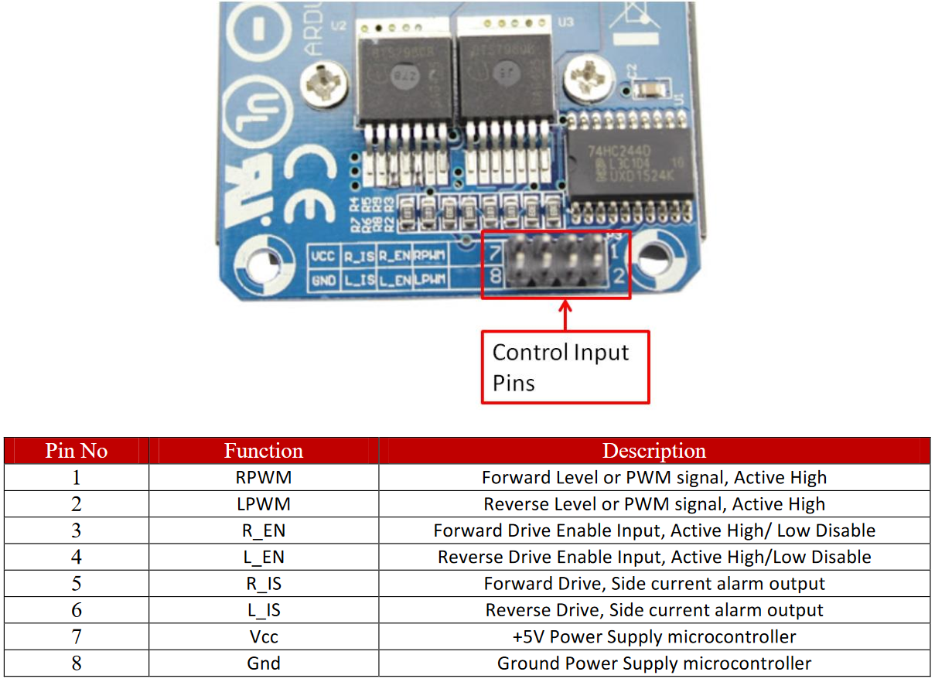
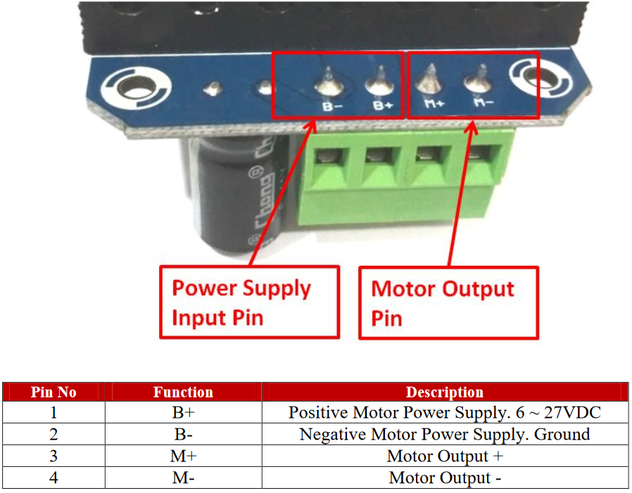
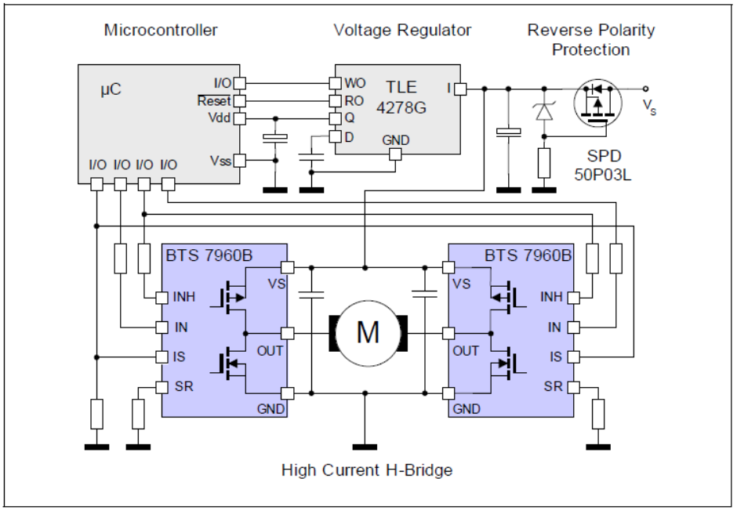

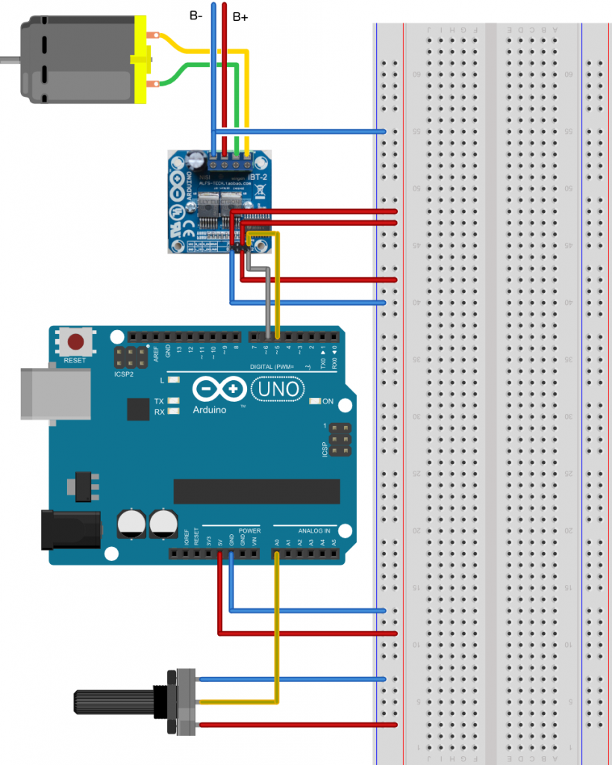

/*******************************************************
Program : MOTOR DRIVER H-BRIDGE MODULE IBT-2
********************************************************/

#define POTENSIO_PIN 0 // Pin Potentiometer A0
#define RPWM_PIN 5 // Digital Pin 5 Arduino Arduino
#define LPWM_PIN 6 // Digital Pin 6 Arduino Arduino

void setup()
{
pinMode(RPWM_PIN, OUTPUT);
pinMode(LPWM_PIN, OUTPUT);
}

void loop()
{
// sensor value range 0 to 1023
int sensorValue = analogRead(POTENSIO_PIN);

// reverse rotation
if (sensorValue < 512)
{
int reversePWM = -(sensorValue - 511) / 2;
analogWrite(LPWM_PIN, 0);
analogWrite(RPWM_PIN, reversePWM);
}

else{
// forward rotation
int forwardPWM = (sensorValue - 512) / 2;
analogWrite(LPWM_PIN, forwardPWM);
analogWrite(RPWM_PIN, 0);
}
}

